**Task No. 1:** Explore HTOP, including its options. Attach outputs for the same.

**Solution:**

HTOP command in Linux System is a command line utility that allows the user to interactively monitor the system’s vital resources or server’s processes in real time.

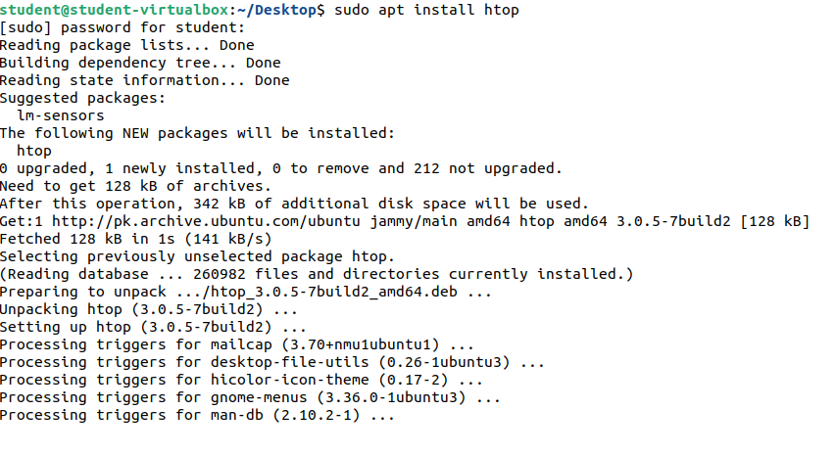

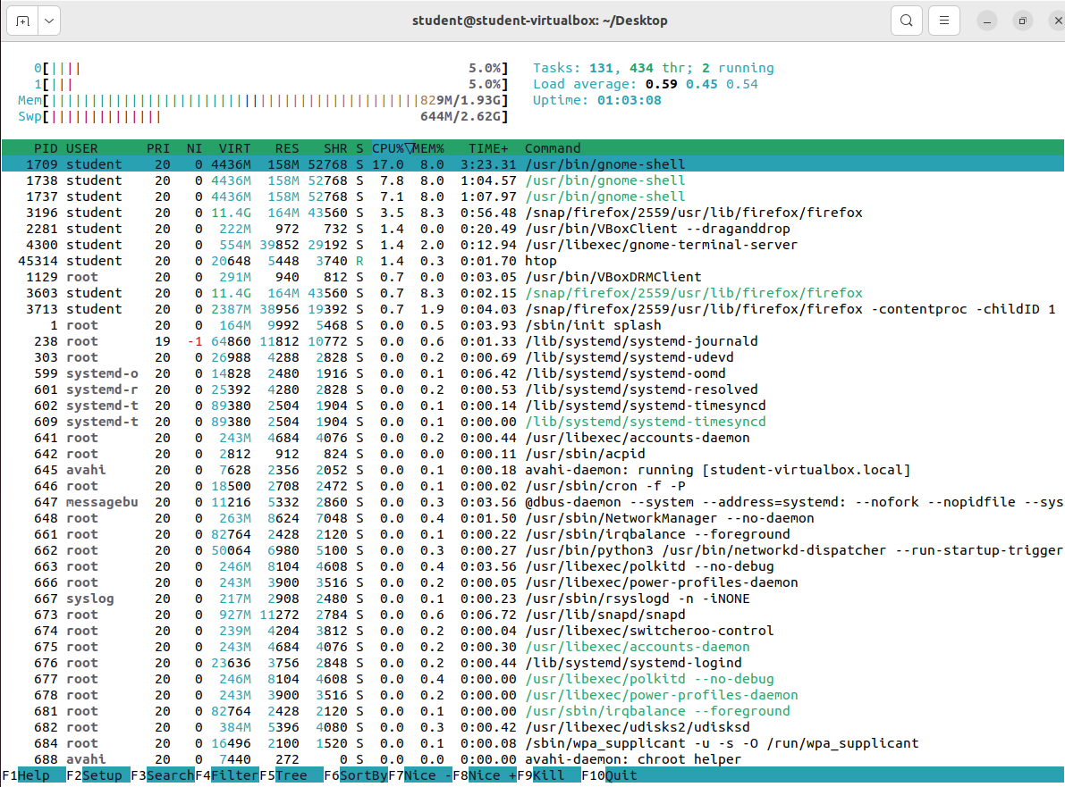**Output:**

* Htop -h ( Help )

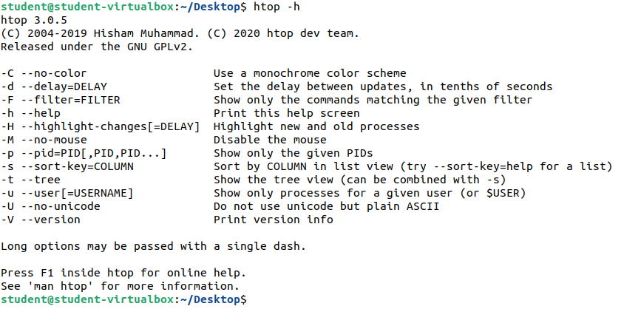

* F5 Tree

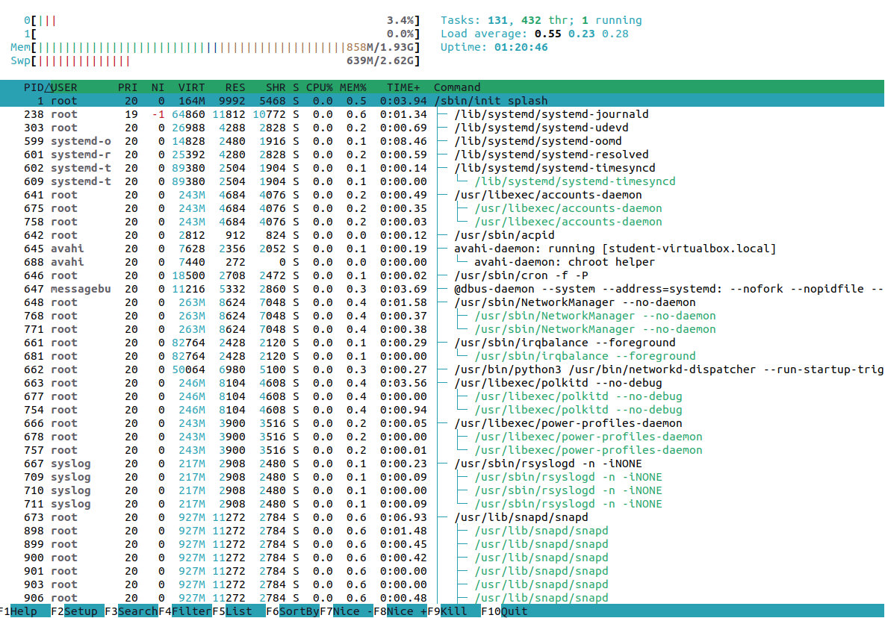

**Task No. 2:** Write a multithreaded C program for performing summation of numbers.

**Solution:**

#include <stdio.h>

#include <unistd.h>

#include <pthread.h>

int sum;

int array[2];

void *AddNumbers(void *arg);

void main()

{

pthread_t thread1;

printf("Enter Number 1: \n");

scanf("%d", &array[0]);

printf("Enter Numnber 2: \n");

scanf("%d", &array[1]);

pthread_create(&thread1, NULL, AddNumbers, array);

pthread_join(thread1, NULL);

}

void *AddNumbers (void *arg)

{

int * arr = (int *) arg;

int n1= arr[0];

int n2= arr[1];

sum = n1 + n2;

printf("\nSum of both numbers = %d \n", sum);

pthread_exit(0);

}

**Output:**

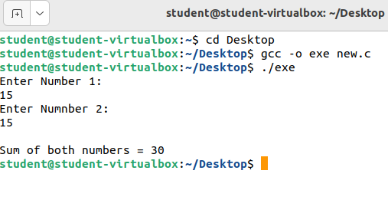

**Task No. 3:** Write a program which make 4 threads. Each thread will print one table out of [5678] up to 1000.

**Solution:**

#include <stdio.h>

#include <unistd.h>

#include <pthread.h>

int num = 5;

int array[3];

void * Tables(void *arg);

void main()

{

pthread_t thread1;

pthread_t thread2;

pthread_t thread3;

pthread_t thread4;

for (int i = 0; i < 4; i++)

{

array[i] = num;

num++;

}

num = 5;

pthread_create(&thread1, NULL, Tables, array);

pthread_join(thread1, NULL);

num++;

pthread_create(&thread2, NULL, Tables, array);

pthread_join(thread2, NULL);

num++;

pthread_create(&thread3, NULL, Tables, array);

pthread_join(thread3, NULL);

num++;

pthread_create(&thread4, NULL, Tables, array);

pthread_join(thread4, NULL);

}

void *Tables(void *arg)

{

for (int i = 1; i <= 1000; i++)

{

switch (num){

case 5:

printf("%d x %d = %d\n", array[0], i, array[0] * i);

break;

case 6:

printf("%d x %d = %d\n", array[1], i, array[1] * i);

break;

case 7:

printf("%d x %d = %d\n", array[2], i, array[2] * i);

break;

case 8:

printf("%d x %d = %d\n", array[3], i, array[3] * i);

break;

}

}

pthread_exit(0);

}

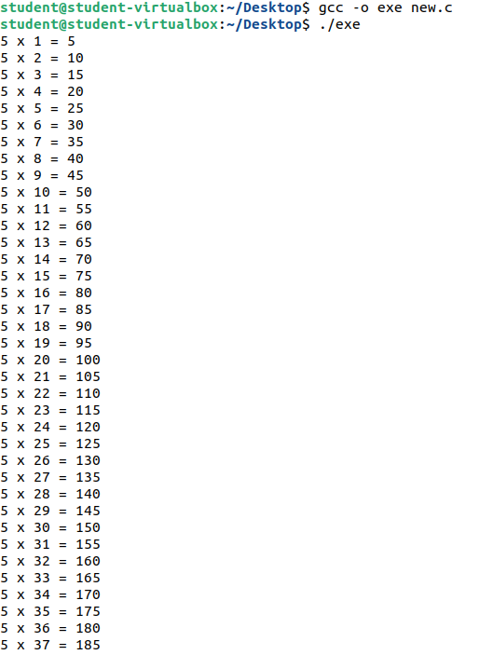**Output:**

